 

**MIDDLE EAST TECHNICAL UNIVERSITY**

**DEPARTMENT OF ELECTRICAL & ELECTRONICS ENGINEERING**

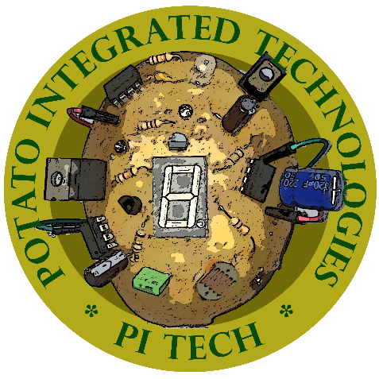

**Potato Integrated Technologies**

**Critical Design Review Report**

**Project: Devices Trying to Score in Each Other’s Goals**

**Duration: 01/10/2018 – 01/06/2019**

**Estimated Cost: $200**

**Design Studio Coordinator: Arzu KOÇ (Section 5)**

|  |  |  |  |  |
| --- | --- | --- | --- | --- |
| **COO**  İrem COŞKUN  2030419  +90 539 414 5969 | **CMO**  Berkay  GÖKSU  2030757  +90 505 635 8145 | **CTO**  Furkan Bahadır  ELİK  2030518  +90 554 963 9410 | **CEO**  Fatma Nur  ARABACI  2030047  +90 533 602 7527 | **CFO**  Aycan  BEYENİR  2030328  +90 539 330 0570 |

# Executive Summary

This report presents details of the project for a teleoperated robot trying to score in opponent’s goal and defend its own meanwhile. Remotely controlled robots are widely used in many aspects of our life. Main idea behind this project reflects a real-world problem in occasions where the user has no view of the robot. Therefore, a two-way communication with the robot and user’s computer should be established. Reliability and efficiency of this communication is vital since intervening a distant robot which can be unreachable at that instant, by the user can be challenging.

This design will be accomplished by building an efficient communication, a robust mechanical design and reliable electronic system. We aim to achieve satisfactory performance in speed and accuracy. Our final product is to detect the ball on the field, shoot the ball towards the opponent’s goal, defend its goal and stay in its half field doing so. Several solution methods are sufficiently described in the following sections of this report.

Our company is composed of five shareholders with different specialization fields and backgrounds. Therefore, each team member came up with a solution from a different point of view. We merged these perspectives in order to construct solution approaches at this point of our design process.

Mission of our company is to provide creative and reliable solutions that fulfill the needs of industry in the field of Industrial robot applications while or vision is to become the most compelling technology company by driving the Industry’s transition to smart manufacturing.

Even though our base knowledge is similar, each team member chose to study in different fields. Therefore, at certain levels of the design process and solution offering, each member has a different idea and experience. Ms. Arabacı is more experienced in controller design and system modelling which will help her to guide and inform the team, Ms. Coşkun and Mr. Göksu will lead the team with their programming skills. Mr. Beyenir’s knowledge in electronics will help us in the integration stage and last but not least Mr. Elik will take an active role in building a durable and stable communication system.

Final product will be delivered in best way with a cost of 200$, at the end of 7 months by PITECH engineers. Once the customer purchases the final product, they will own the final action robot consisting of mechanical subsystems, camera, sensors and drivers. In addition to these, a user manual, a warranty document, required software tools, four batteries, battery chargers, three game field walls, two balls (one is extra) and a dummy robot are also provided.

# Introduction

In the last few decades, robots are gaining more complex abilities, thanks to improvements of technology, that they substitute for humans in many fields of industry. This progress enables us to handle things easier and, in more time, efficient way since their performance is better than ours in many aspects of our daily life such as personal, professional life etc.

Being a newly founded company with five highly motivated, young engineers from different specialization fields such as electronics, control, computer and telecommunications; our aim is to develop a teleoperated robot that can play hockey which includes trying to score in opponent’s goal and also defend its own goal. Apart from the specifications defined above we intend to come up with the best featured robot possible.

In this project, our main purpose is to build a robot that we can control from a specified distance with a remote controller. Also, this robot should be controlled without actually monitoring the play-field with naked eye; the only means of monitoring the field is by means of a camera mounted onboard the robot. Wi-Fi connection is not allowed for transmission, that is the reason why we are using RF communication to transmit the data. In addition to that, the robot is not allowed to cross the center-line into opponent’s half-field. Another requirement is that the ball must be transferred to opponent’s half-field in no more than 20 seconds.  Robots can hit, push or otherwise drive the ball but not grasp, scoop or otherwise carry it.

In order to fulfill these requirements, we found an efficient way to transfer data from our robot to the main computer so that we can improve our chance to score a goal and win the round. This is a two-way communication since we will send directions to the robot so that it can move with respect to these commands. In addition, the mechanical structure of the robot should also be robust so that it can endure possible encounters with the ball. While developing the design, it should be noted that both mechanical and electrical solutions support each other. To sum up, this project and its solutions may contribute to the areas where teleoperated robots are used for many different purposes.

In this report, a detailed analysis of this project is presented. Description of overall system and subsystems is presented in this report. In addition to that, drawings, block diagrams, flow charts, test results, cost analysis, time plan can be found in following sections of this report.

# Overal system desc

## A

## B

### A

### B

### C

### D

### E

### Main Processor Subsystem

#### Solution Approach

Our plan for main processor subsystem is to use Arduino Mega. Figure 3.2.6.1.1 below shows an Arduino Mega.

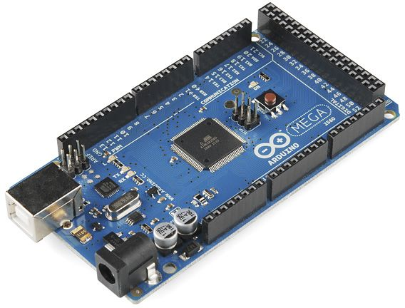

Figure 3.2.6.1.1 Arduino Mega [4]

Our main plan is to use Arduino Mega for main processor subsystem it is chosen because it has variety of I/O pins which makes it possible for us to use only one processor for robot side. Also, Arduino has a variety of online sources that are easily reachable which makes it easier to program. Arduino MEGA will used to control motors, shooting system motor and command receiver module on robot side.

We are going to use an Arduino UNO in the tele controller side as a processor. The reason why we use UNO instead of MEGA in tele controller part is that we do not need higher DC current or higher number of pins that MEGA offers in tele controller part. Figure 3.2.6.1.2 below shows an Arduino UNO.

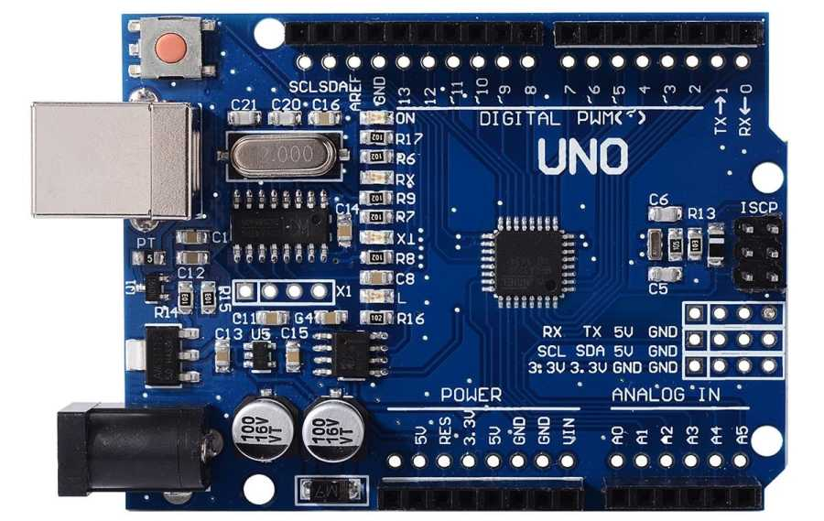

Figure 3.2.6.1.2 Arduino UNO [4]

Arduino UNO will used to control the joystick commands, command transmitting module and video receiving module on tele controller side.

#### Block Diagram & Flow Chart

Figures 3.2.6.2.1-2 below shows block diagrams for main processor subsystem. Signal interfaces are clearly labeled.

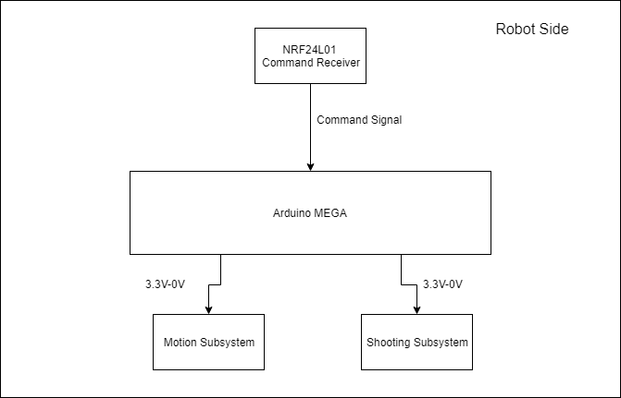

Figure 3.2.6.2.1 Block diagram of processor system at robot side

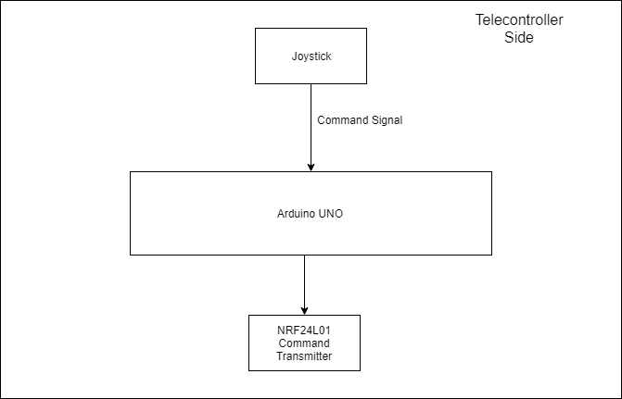

Figure 3.2.6.2.2 Block diagram of processor system on telecontroller side

Figure 3.2.6.2.3 below shows a flow chart for both of the processor system.

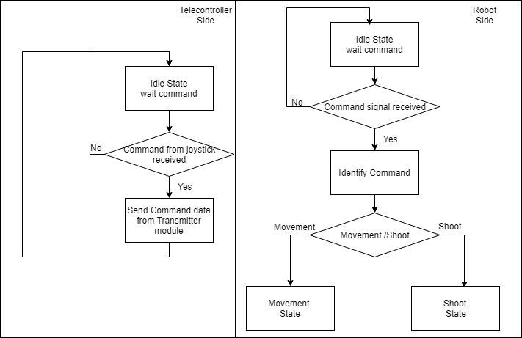

Figure 3.2.6.2.3 Flow chart for main processor subsystem

# Requirements

The goal of this project is to design and construct a teleoperated robot (controlled from a distance up to at least 30 meters) which can compete with a similar robot in shooting and scoring to opponent’s goal. Functional, physical and performance requirements of the system and subsystem levels are as follows:

## Overall System Requirements

Functional, physical and performance requirements of overall system converge all the subsystem requirements. These requirements are as follows:

**Functional requirements:**

* Detect the start signal
* Monitor the surrounding
* Process the monitored data
* Encode the processed data for communication
* Transfer the encoded data to the teleoperator

*If the ball is at players half-field and far away from the robot:*

* Transfer the movement direction command given by the teleoperator, to move toward the ball
* Perform the move operation respect to the command transferred from teleoperator
* Move robot to the ball until ball is in the shooting range
* Transfer the hit the ball command given by the teleoperator
* Perform the hit the ball operation given by teleoperator

*If the ball is at opponent’s half-field:*

* Transfer the movement direction command given by the teleoperator, to cover the goal, given by the teleoperator
* Perform the move operation respect to the command transferred from teleoperator
* Move robot to the own goal to protect it from the incoming shoot
* Protect the goal respect to the commands from teleoperator

**Physical requirements:**

* Goals must be at least twice as wide as their defenders’ lateral dimensions.
* Robots can hit, push or otherwise drive the ball but not grasp, scoop or otherwise carry it. So, robot cannot have a grasping or scooping part.
* The playfield should be regular hexagon on a bare floor, with center-line and goal lines marked by “masking tape”.
* The playfield constructed from 6 sidewalls of 70-75 cm length each and two goals snugly fit at the opposite corners, while preserving symmetry.
* The robot should fit in a 40 cm diameter cylinder.
* In order to move fast enough our motors should carry the weight of the remaining parts.
* Weight should be aligned in center for steady and controllable movement.
* Robot should be less than 3 kgs in total.
* Shooting plate should be larger than the dimensions of ball.
* The ball should not move under the robot in any condition so the distance between robots first stage and floor should be less than 5 cm.

**Performance requirements:**

* Ball should be transferred to opponent’s half-field in no more than 20 seconds.
* The operator remotely controls the robot from a distance up to at least 30 meters indoor.
* The transmission delay between the robot and receiver should be less than 0.5 seconds.
* The robot should be able to work with at least 2 kg load.
* The robot’s shooting mechanism should be strong enough to throw the ball to opposing goal with one push from its own goal area.
* Robot should move from one end to half field in last than 3 seconds.
* Detection subsystem should be able to work in different lightning conditions.
* Main processors operate different operations in parallel.
* All system should work more than 15 minutes without the need of battery charging.

## Subsystem Level Requirements

Different subsystems of the project have different requirements. This section of the report covers these requirements.

### Power Supply Subsystem Requirements

Functional, physical and performance requirements for power supply subsystem is as follows:

**Functional Requirements:**

* Power supply subsystem should supply power to all other subsystems.
* Required different voltage and ampere values should be generated by power supply subsystem.

**Physical Requirements:**

* Power supply system at the robot side should be less than 250 gr.
* Power supply system at the controller side should be less than 80 gr.
* Battery in the controller side should fit in a box with dimensions 80x25x25mm.
* Battery in the robot side should fit in a box with dimensions 40x50x25mm.

**Performance Requirements:**

* Both power supply system at the robot side and the controller side should supply 5V and 12V.
* The temperature of batteries should not reach 60⁰. [1]
* Controller side should not draw more than 5A in order to have operation approximately 10 minutes. To operate the system more than 15 minutes the power system should supply less than 3.6A. [2]
* Robot side should not draw more than 15A in order to have operation approximately 10 minutes. To operate the system more than 15 minutes the power system should supply less than 10A. [2]

### Communication and Telecontroller Subsystem Requirements

Functional, physical and performance requirements for communication and telecontroller subsystem is as follows:

**Functional Requirements:**

* Detect the start signal.
* Monitor the surrounding.
* Process the monitored data.
* Encode the processed data for communication.
* Transfer the encoded data to the teleoperator.
* Transfer the movement direction command given by the teleoperator, to move toward the ball.

**Physical Requirements:**

* The weight of communication and telecontroller subsystem at the robot side should not exceed 250gr.
* Individual elements of this subsystem should fit in a box with dimensions 110x60x50mm. (The element which has the maximum volume is Arduino MEGA so the others should be smaller than Arduino MEGA.) [3]

**Performance Requirements:**

* The transmission between the robot and receiver should be less than 0.5 seconds.
* The operator remotely controls the robot from a distance up to at least 30 meters indoor.

### Shooting Subsystem Requirements

Functional, physical and performance requirements for shooting subsystem is as follows:

**Functional Requirements:**

* The subsystem should be able to push the ball with the shoot signal.

**Physical Requirements:**

* Shooting plate’s height should not be higher than 6 cm in order to not exceed first floor of the robot.
* The weight should be less than 100 gr.
* Shooting plate should be larger than the dimensions of ball.

**Performance Requirements:**

* The robot’s shooting mechanism should be strong enough to throw the ball to opposing goal with one push from its own goal area.

### Motion Subsystem Requirements

Functional, physical and performance requirements for motion subsystem is as follows:

**Functional Requirements:**

* This subsystem should perform the move operation respect to the command transferred from teleoperator.
* Robot should move towards the ball until ball is in the shooting range.
* Robot should move towards its own goal to protect it from the incoming shoot.

**Physical Requirements:**

* The weight of total subsystem should be less than 1000 gr.
* Individual elements of this subsystem should fit in a box with dimensions 120x60x100mm.

**Performance Requirements:**

* Robot should move from one end to half field in last than 3 seconds.
* Motors should carry at least 2 kg weight while satisfy other requirements.
* This subsystem should not drive more than 4A. (2A for each motor)

### Detection Subsystem Requirements

Functional, physical and performance requirements for detection subsystem is as follows:

**Functional Requirements:**

* Robot should monitor the surrounding.
* Robot should transmit the surrounding data.

**Physical Requirements:**

* The weight should be less than 100 gr.

**Performance Requirements:**

* Detection subsystem should be able to work in different lightning conditions.
* Detection subsystem should transmit data with less than 0.5 seconds delay.

### Main Processor Subsystem Requirements

Functional, physical and performance requirements for main processor subsystem is as follows:

**Functional Requirements:**

* This subsystem should be able to control the other subsystems with the same processor.

**Physical Requirements:**

* The weight should be less than 50 gr for both robot side and controller side.

**Performance Requirements:**

* Main processors operate different operations in parallel.

# A

# B

# Test Procedure

## A

## B

## B

## B

## B

## Main Processor Subsystem

Main processor subsystem only consists Arduino’s so for this subsystems test procedure the only thing that should be tested is the operations of Arduino’s.

**Power Test:** Power test will be conducted under different voltage supplies. At the end we won’t supply Arduino’s from computer or powerbanks so Buck converter output should be connected to Arduino to test the operations. If it is turning on this test will be successful. We tried it with power supply and it turned on, so this test resulted successfully.

**Simultaneously Parallel Operation Test**: Since we want the work different operations in parallel, a test should be conducted while shooting, motion and receiver modules are connected. All of them worked successfully during the test, so result is successful.

# Compliance with Requirements

## Design Decisions and Requirement Correlations

Requirements are given in section 4 of this report.

* As our main processor we selected Arduino MEGA on robot side in order to do operations is parallel. As mentioned in one of our performance requirements is to work different operations simultaneously and parallel. Since Arduino MEGA has 54 Digital I/O pins and 16 Analog Input pins [4]. Also, Arduino MEGA offers higher speed than its components.
* We designed two story robot body in order to comply with the requirement that is the robot should fit in 40 cm diameter cylinder. This requirement is decided by our company to create a smaller robot body which results smaller goal.
* The motors are connected on top of the first stage of the robot to comply the physical requirement that the ball should not pass under our robot.
* We designed our shooting plate approximately 8*5 cm to comply the requirement that the shooting plate should be bigger than the ball.
* We designed our robot to comply with the requirement that weight is aligned in the center. In robot we have 2 motors, 2 motor drivers they aligned symmetrically, and other elements are aligned at center.
* Since in requirements it is stated that it is not allowed to grasp, pull etc. we decided to have a pushing shooting system.
* BAHO neden nrf kullandık bunun range ozellikleriyle falan eşleştir.
* FATO motor hızlarıyla şunları eşleştir. Ball should be transferred to opponent’s half-field in no more than 20 seconds.Robot should move from one end to half field in last than 3 seconds.
* To comply with the power requirements, at telecontroller side we are going to use 900 mAh Li-po battery. This battery is going to give telecontroller approximately 30 minutes of operation. Because during our tests video receiver and command transmitting module approximately draws 1.5A. So, this result complies with the requirement that system should work more than 15 minutes.
* To comply with the power requirements, at robot side we are going to use 2900 mAh Li-po battery. This battery is going to give robot approximately 40 minutes of operation. Because during our tests video transmitter, command receiver, motion subsystem and shooting subsystem module maximum draws 3.5A. So, this result complies with the requirement that system should work more than 15 minutes.

## Conflicting Requirements and Trade-offs

* We are using Li-po batteries which are heavy parts and increases the weight of our robot and telecontroller but they comply the power requirements.
* Arduino MEGA has more than 50 pins and faster response but on the other hand it is one of the most expensive items of our robot. We considered cost as a requirement in that case.
* Our motors comply the speed and torque requirements, but these motors are heavy and big parts. The length of one motor with wheel is approximately 10 cm so these motors limits our body diameter.
* Our video transmitter is small and transmission power is high which complies the requirement on the other hand the temperature increases so it needs heatsink and fan which add weight to our system.

## Discussion on Robustness

We used plexiglass material for the body of our robot which is durable material. All the elements are attached permanently to the body so, robot structure is not going to be affected by outside sources. All the cables are attached to the body to avoid cluttering. We are using Arduino programming which is easy, and our code does not have any errors because this code is used by other user throughout the time. This open source code has lower change to have an error. Power system has a switch and it is detachable for easy use. For testing 10 times doing the same operation our robot gave the same response every time. We made hardware tests and each element gave consistent response. To avoid overheating we placed fans and heatsinks, so our robot is not going to be affected by temperature changes.

# Resource Management

## A

## B

## Gantt Chart

Gantt Chart of Potato Integrated Technologies can be found in Figure 9.1.1.

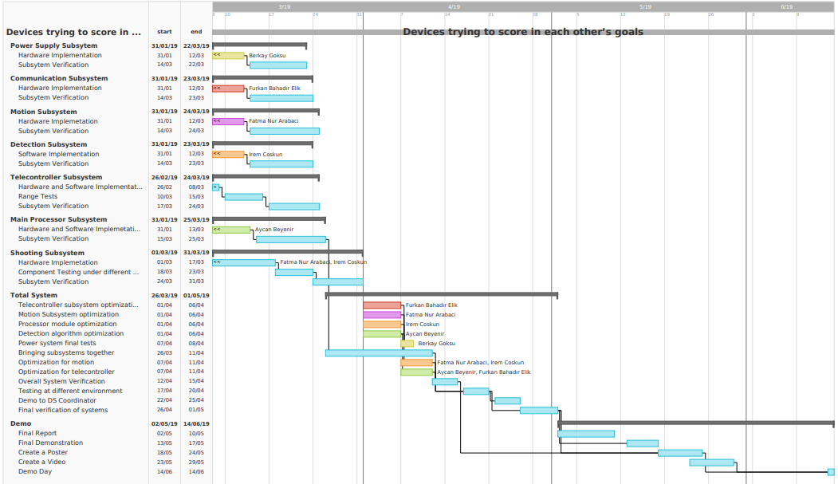

Figure9.3.1: Gantt chart of PITech

# Conclusion

The main focus of this critical design report is to ensure that the system under review can proceed into system fabrication, demonstration, and test; and can meet the stated performance requirements within cost (budget), schedule, and other system constraints. In this report we presented our system design for the previously stated problem, “Devices Trying to Score in Each Other’s Goals”, namely a robot that communicates with the controller and via remote operator, tries to score on opponent’s goal. We changed some of our previously stated in ideas in conceptual design report and these design modifications described with clear justifications.

Detailed requirements for both system level and subsystem level were presented in this report with top-down approach. Also, justification of the parts that are not modified was given with the justifications to satisfy the customer and engineering requirements. In addition to that test results, encountered problems and proposed solutions are presented.

Compatibility analysis of sub-blocks are discussed, and signal interfaces are clearly described. This report also includes the correlation between the requirements and decisions. At the end of the report we presented our modified cost analysis, modified and up-to-date Gantt Chart. A power distribution diagram and power management analysis were also provided.

To conclude, this report contains all the parts of our design with clear justification. We are planning to implement this design without changing the essential parts of the system design. Our main goal is using the most practical and simple solution that would not create redundant complications for this product is to be used in various real-life applications. So, we Potato Integrated will deliver an exceptional final product together with the deliverables, within a short timeframe and economic budget. Our aim as an ambitious company to thrive on everyday problems with topnotch products with performance and durability.

As PITech engineers, we tried to find the best solution within $200 budget that will fulfill the requirements and satisfy the customer. This report is to shows that our system under review can proceed into system fabrication, demonstration, and tests. We are confident and showed that our design meets the stated performance requirements within cost (budget), schedule, and other system constraints.

# References

[1] Here's all you should know about LiPo Batteries. (2019). Retrieved from <https://www.myrcbox.com/articles/tech-article-what-you-should-know-about-lipo-batteries/>

[2] Multicopter build log. (2019). Retrieved from <http://multicopter.forestblue.nl/lipo_need_calculator.html>

[3] Arduino Mega 2560 Rev3. (2019). Retrieved from <https://store.arduino.cc/usa/mega-2560-r3>

[4] Store.arduino.cc. (2018). *Arduino Mega 2560 Rev3*. [online] Available at: <https://store.arduino.cc/usa/arduino-mega-2560-rev3>